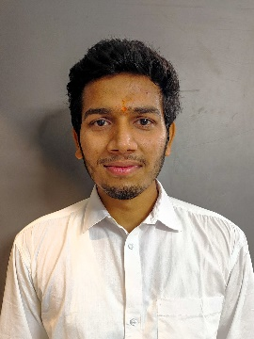

Registration Number: 20BCE11028

Email: abhishek.ranjan7602@gmail.com

Phone: +91 8002892991

https://www.linkedin.com/in/abhishek-ranjan-82b4b223b/

https://github.com/ranjanabhi07

**Abhishek Ranjan**

**Technical Skills:** Java, DSA, Node.js, Mongo dB, HTML, CSS, JavaScript

**Certification:**

* AWS Cloud Practitioner
* Java data structures and algorithms masterclass, Udemy, April 2023
* The complete web development bootcamp (MERN Stack), Udemy, May 2023

|  |  |  |  |
| --- | --- | --- | --- |
| **EDUCATION** | | | |
| **Board** | **Tenure** | **Educational institution** | **CGPA/Percentage** |
| B. Tech (CSE) | May 20 –Ongoing | Vellore Institute of Technology, Bhopal | 7.80/10 |
| Class XII | May 19 | Park Mount Public School | 78.8% |
| Class X | May 17 | Adarsh Vikas Vidyalaya | 9.4/10 |

|  |  |
| --- | --- |
| **ACADEMIC PROJECTS** | |
| Full Stack Web Development | * **To-Do-List (Feb 2023- March 2023)**   + Description: full stack project (having database connected) have multiple functions.   + Technology: html, CSS (bootstrap), mongo dB (mongoose), node.js (express.js), and many other API’s.   + Solo Project   + GitHub link: https://github.com/ranjanabhi07/todolist-v2 |
| Backend Development | * **Secret/personal Diary (March 2023 – April2023)**   + Description: This app combines of Security and Authentication with database and highly secured website.   + Technology: Authentication & Security (passport.js), node.js, mongoose, html, CSS, bootstrap.   + Solo Project   + GitHub link: https://github.com/ranjanabhi07/Authentication-Secret |
| Full Stack Web Development | * **Hospital Website (April 2023 – ongoing)**   + Description: hospital website, containing doctors and patients’ details, reports, appointment, etc.   + Technology: PHP, html, CSS, bootstrap   + Solo Project   + GitHub link: https://github.com/ranjanabhi07/hospital-website- |

|  |  |
| --- | --- |
| CO-CURRICULARS | |
| Coding | * Leetcode – 100+ Question in java |

|  |  |
| --- | --- |
| EXTRA-CURRICULARS AND ACHIEVEMENTS | |
| Responsibilities | * Core Member, Sports club, VIT Bhopal. |

|  |  |
| --- | --- |
| ADDITIONAL INFORMATION | |
| Hobbies | * Sports (cricket, football, basketball) * Drawing, painting, Designing |
| Languages | * Hindi, English |